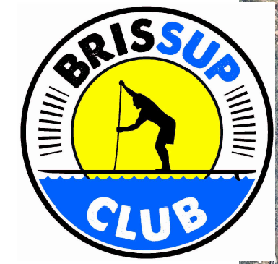
INSTRUCTIONS
Tingalpa-Lota Creek Treasure Hunt Paddle
Sunday 23 July 2023
Time: Meet at 11:15am to prepare. Treasure Hunt starts 12 noon after the event briefing.
Location: Wynnum Redlands Canoe Club boat ramp, Railway Parade, Thorneside
The treasure hunt will take the form of a fun two hour Paddle-o-gaine, which is a bit like orienteering on SUPs.
Teams: You will work in teams of 2-4 people. You can form your own team or join a team on the day. Teams will be given maps & checkpoint cards.
Members of each team must stay together and all team members must be with each other at all checkpoints.
Aim: To use your maps and clues to paddle and find as many check points as you can in the two hour limit.
Timing: Teams all start together and will have a max. of two hours on the course. You can pick your own route and go in any direction you like. Teams must return to base within 2 hours. A penalty of loss of points per minute over the time limit will apply.
Using the maps: Maps will be printed on A3 paper. Tape and plastic sleeves will be supplied to waterproof & tape maps to your SUPs.
Maps: The maps cover the area from Wynnum Redlands Canoe Club up Lota Creek, down to Tingalpa Creek mouth and 3-4 km up Tingalpa Creek. Some teams may only use one map.
Map 1 - Northern – Railway Bridge – Lota Creek – Waterloo Bay. Tingalpa Creek downstream of the railway bridge.
Map 2 - Southern – Tingalpa Creek upstream of the railway bridge. Up to the fishing platform at Chadwell street.
Checkpoints: This year all the checkpoints will be marked with PINK, GREEN or ORANGE fluoro coloured tape and can be found on mangroves & other trees on the river. There are no checkpoints on land.
Clues: Clues are printed on the maps (there are no separate clue sheets).
You will use laminated checkpoint cards to mark the clues as you go. Attach the cards with pieces of elastic on your wrist, waist belt or hydration pack. Mark with a pen. String & elastic supplied.
Scoring: Checkpoints will be numbered according to value. The further away and more difficult to find checkpoints have higher value:
- 101, 102 etc. = 10 points each
- 201, 202 etc. = 20 points each
- 301 , 304 = 30 points
- 401, 403 – 40 points
- 501 – 50 points
NAVIGATION TIPS
- Check point values increase with the degree of difficulty of the clue and especially the distance from the start. The more check points you find, the more points you score.
- Take 5 to 10 mins. to read your map and clue sheet and to plan your route with your team. This will make navigation on the move much easier.
- Pick your route to match the ability of the team.
- It is not about paddling the fastest or furtherest, but carefully reading the map and clues, choosing your route wisely and not underestimating how long it will take to get back to base!
- It is a rising tide during the event. But watch out for the shallow areas out in the bay and along the narrow creeks before high tide.
- Will you gamble and paddle hard and try to get the high scoring check points far away, or will you focus on Lota Creek with lots of check points?

What to bring
- Leg ropes/leash are compulsory safety equipment
- A water bottle or hydration pack
- Thongs/booties if needed
- Windproof top, booties etc. suitable for a winter paddle & the weather on the day

