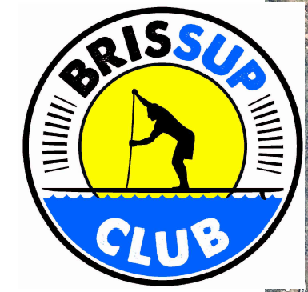
INSTRUCTIONS
Tingalpa-Lota Creek Treasure Hunt Paddle
Sunday 17 July 2022
Time: Meet at 10:45am Treasure Hunt starts 11:15am after the event briefing.
Location: Wynnum Redlands Canoe Club boat ramp, Railway Parade, Thorneside
The treasure hunt will take the form of a fun two hour Paddle-o-gaine, which is a bit like orienteering on SUPs.
Aim: To use your maps and clue sheet to paddle and find as many check points as you can in the two hour limit.
Teams: You will work in teams of 2-4 people. You can form your own team or join a team on the day. Each team will have two maps and two clue sheets. Pick which members in the team will look after the maps and the clue sheets.
Members of each team must stay together and all team members must be within 10m of each other at all checkpoints.
For the few clues on land, only one person from each team needs to get off their board and go find the check point clue. The others must wait close by.
Timing: Teams will all start together and will have a max. of two hours on the course. You can pick your own route and go in any direction you like. Teams must return to base within 2 hours. A penalty of loss of points per minute over the time limit will apply.
Using the maps: Maps will be printed on A3 paper. Tape and plastic sleeves will be supplied to tape maps to your SUPs. If you have a map case or another way to hold your map you are welcome to bring it along.
Clue sheets: Clue sheets will be on A4 paper. The numbered clues will be a manmade landmark or a coloured tag on a tree with an A, B or C choice. Mark your selection on the clue sheet. Plastic sleeves, pens and/or pencils provided.
Checkpoints will be numbered according to value. The further and more difficult checkpoints have higher value:
- 101, 102 – 10 points; 201, 202 etc. – 20 points; 301 , 304 – 30 points; 401, 403 – 40 points; 501 – 50 points
Maps: The mapped area we will be using starts at the Wynnum Redlands Canoe Club and covers Lota Creek, down to Tingalpa Creek mouth and 3-4 km up Tingalpa Creek. Some teams may only use one map
Map 1 - Treasure Hunt Northern – Railway Bridge – Lota Creek – Waterloo Bay. Tingalpa Creek downstream of the railway bridge.
Map 2 - Treasure Hunt Southern – Tingalpa Creek upstream of the railway bridge.
NAVIGATION TIPS
- The maps will have numbered check points scattered from the start at the canoe club boat ramp up Lota Creek, down to Waterloo Bay at the mouth of Tingalpa Creek, and also approx. 3 – 4 km up the creek to the boat ramp at Chadwell street.
- Check point values increase with the degree of difficulty of the clue and especially the distance from the start. The more check points you find, the more points you score.
- Taking 5 to 10 mins. to read your map and clue sheet and to plan your route with your team will make navigation on the move much easier.
- Pick your route to match the ability of the team.
- It is not about paddling the fastest or furtherest, but carefully reading the map and clues, choosing your route wisely and not underestimating how long it will take to get back to base!
- It is a rising tide during the event on 17 July 2022. But watch out for the shallow areas out in the bay and along the narrow creeks before high tide.
- Watch out for the narrow and shallow side creeks – they could get crowded.
- Will you gamble and paddle hard and try to get the high scoring check points far away, or will you focus on Lota Creek with lots of check points?

What to bring
- Leg ropes/leash are compulsory safety equipment
- A water bottle or hydration pack
- Thongs/booties if needed
- Windproof top, booties etc. suitable for a winter paddle & the weather on the day

